Digital Forensic Analysis Report

This report presents a comprehensive forensic investigation of a confiscated Apple iPhone 8 using the advanced tools XRY (v9.4.3) and XAMN (v7.1). The analysis focuses on the extraction, preservation, and examination of digital evidence from a jailbroken device belonging to Karl Agathon.

The investigation covers various components, including:

**Device Information:** Detailed specifications and identifiers such as IMEI, subscriber ID, device status (jailbroken), and contact information.

**Application Users and Communications:** The device shows frequent interactions with contacts across multiple platforms including WhatsApp, Facebook Messenger, KakaoTalk, and Discord. Notable contacts include John Bear, Fozzy Bear, and Iamthewarrior.

**Applications and Features:** Apps like WhatsApp, Snapchat, TikTok, and Zello were used for multimedia sharing and encrypted communication, with suspicious content such as weapons, fake certificates, bank cards, and large sums of money exchanged.

**Acquisition & Preservation:** Two XRY images were taken—one from the original phone and one from the jailbroken state—to ensure evidence integrity.

**Examination and Analysis:** The phone's media gallery included images of firearms, bullet metadata, location-tagged videos, and possibly forged documents. Text and audio messages suggest discussions around illicit activity, including vehicle theft.

**SQLite Databases:** The report highlights the role of SQLite in storing communication and media data in apps like WhatsApp and Facebook.

**Data Recovery:** Despite deletions, evidence was recovered across various apps (e.g., WhatsApp, Viber), with some deleted items re-extracted.

**XAMN Element Use:** The XAMN viewer was instrumental in organizing, analyzing, and correlating the extracted data, and generating court-admissible reports.

**Metadata Analysis:** Metadata related to files, locations, timestamps, and app usage was examined to build timelines and user behavior profiles.

Table of Contents

**Introduction**

Software Information

Application Users

Features of Applications

**Acquisition and Preservation**

**Examination and Analysis**

Media

Communication

Locations

Metadata

List Evidence

**SQLite**

**Retrieve/Recovery Data**

**XAMN Element**

**Metadata of transferred data from a source**

**Executive Summary**

**Introduction:**

The XRY and XAMN tools are strong allies in the rapidly developing field of digital forensics, taking use of the most recent technological developments. This report uses XRY (version 9.4.3) and XAMN (version 7.1) to conduct a thorough analysis of possible mobile or digital evidence. These cutting-edge software programmes act as technological cornerstones, capable of revealing hidden data hidden away in the cracks of the suspected mobile device.

The extraction and analysis of digital evidence from an image of a mobile phone that was confiscated is the main focus of this paper. Using good investigation techniques, forensic inspection uses XRY as a guide to recover and identify relevant data. The organised and thorough methodology of the study attempts to provide court-ready proof of the material found on the suspected disc. In the main body, we explore the complexities of the digital world by examining media, chat logs, files and papers that contain sensitive data, and diving into the realm of evidence that has been wiped. Analysis is conducted across multiple dimensions, such as SQLite databases, XAMN elements, and metadata studies. It provides insights into the status of devices, owner information, user relationships, and social media group dynamics.

1. **Software Information**

| **Operating System** | **Description** |
| --- | --- |
| OS | Apple iOS |
| Device Name | Apple iPhone 8 8 TD- LTE (A1905) |
| Manufacturer | Apple |
| Owner | Karl Agathon 2 |
| Device Family | Phone |
| Contact Number | +1 (603) 306-9611 |
| Email ID | [karlagathon5@gmail.com](mailto:karlagathon5@gmail.com) |
| Device Status | Jail Broken |
| OS Install Time | 2018-12-24 08:03:40 -0500 |
| Bluetooth Adress | 40-9c:28:d7:fd:b7 |
| WiFi Address | 40-9c:28:d7:fd:9c |
| Storage Capacity of the mobile: | 59.6 GB |
| Storage Availability of the Mobile: | 32.9 GB |
| Advertising ID | D5CFBBDE-4EB3-4DE2-9917-833A20F6DC92 |
| Mobile ID (IMEI Number) | 356766088003047 |
| Device Clock: | 28/05/2021 22:01:18 (Device) |
| Subscriber ID: | 310410211062598 |
| Device Time Zone: | America/ New York |

* 1. **Application Users**

These people are continuously in contact with owner of the phone.

| John Bear | Facebook Messenger |
| --- | --- |
| Test1 | WhatsApp |
| Fozzy Bear | Apple Calls |
| Armand Garand | KakaoTalk |
| Iamthewarrior | Discord |

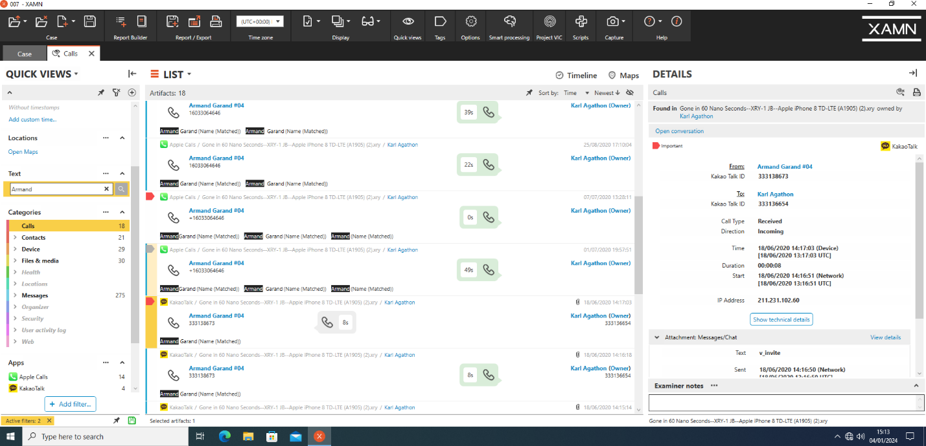

* 1. **Features of Applications**

The iPhone image under investigation offers a wide range of platforms in the always changing world of social media apps, such as WhatsApp, Facebook Messenger, TikTok, Discord, Apple Call, Snapchat, and more. WhatsApp provides end-to-end encryption for instant messaging, phone and video conversations, and status updates. Facebook Messenger offers flexible text, voice, and video chats along with entertaining features like reactions and stickers. TikTok is a creative video-sharing platform where users create short music-accompanied videos. KakaoTalk enhances the experience with text, phone, and video messaging in addition to games and stickers, providing a complete and intuitive communication platform. Every application, designed to meet particular requirements, combines special features with necessary functionality to increase user engagement.

**Acquisition and Preservation:**

Gathering and preserving digital evidence is the task of acquisition and preservation. Two XRY photos were acquired, one of which showed a possible jailbreak and the other the original mobile image. We started gathering evidence to learn more about the case, taking the necessary precautions to identify the underlying motives. The pictures are from an iPhone 8, registered under the username Karl Agathon, that has the aeroplane mode turned off. The network ascertained the time zone, and the SIM condition indicated preparedness.

In order to preserve the validity, generation, and availability of data timestamps, existing procedures require that potential devices be kept switched on. To guarantee the integrity and protection of every genuine piece of evidence, new methods of data gathering and storage must be put in place. The intricacy stems from the fact that multiple data kinds, standards, and communication protocols are involved, more than in traditional computers. The difficulty is further increased by the possibility that evidence is kept on computers connected to the same network or in data centres.

**Examination and Analysis:**

**Media**

I have found a picture of screen may be capture by a phone. In this picture we can see that a Samsung phone model Galaxy J3 is going to be decode. Its suspicious to me.

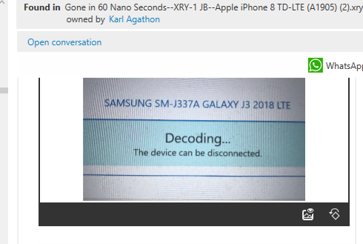

In this picture there are 3 different colors of item.one of these white one looks like drug.

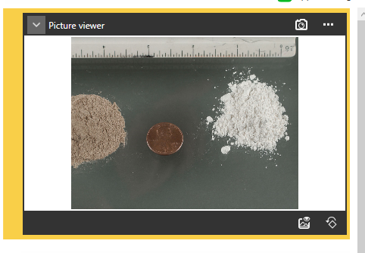

**Firmware version**

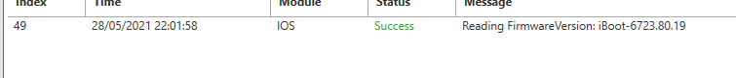

In this scanned copy we can see a certificate of Texas but main this thing is the form is blank. May the owner of phone or someone his friend makes illegal certificate.

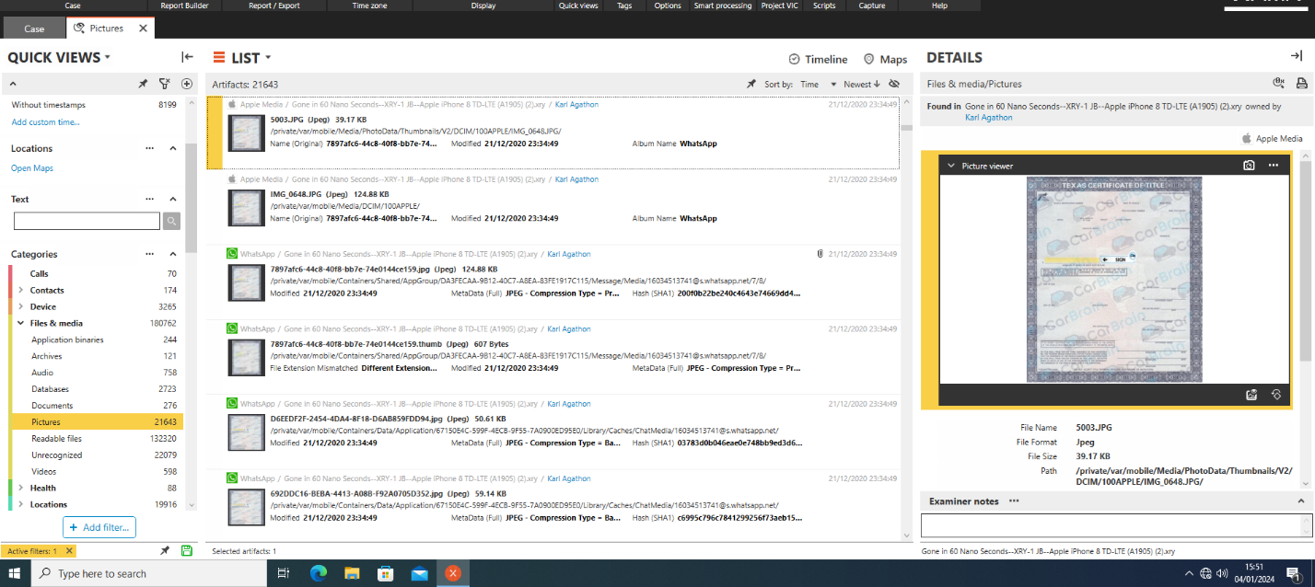

This is the sample of Arizona certificate from same directory.

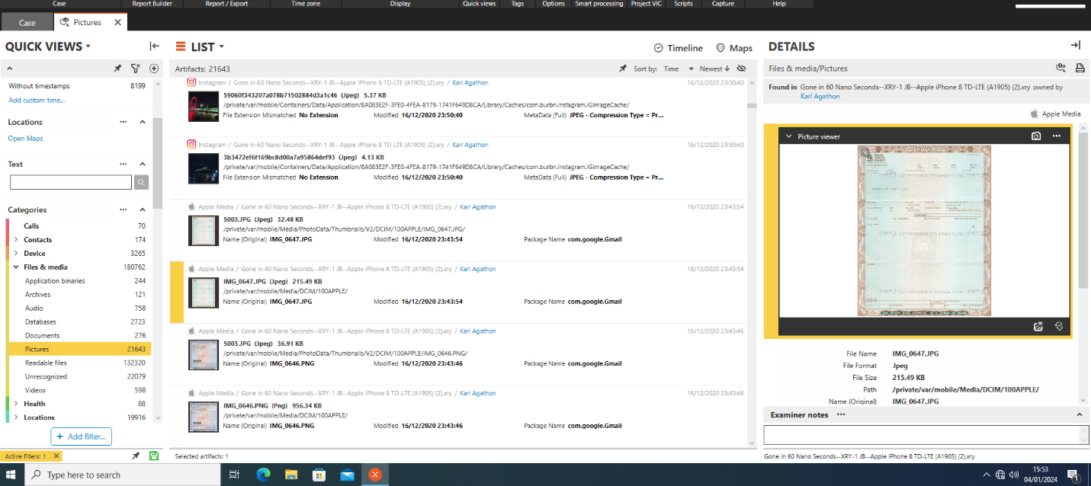

One more sample of certificate from state of Deleware again from the same directory. The sample is written with watermark.

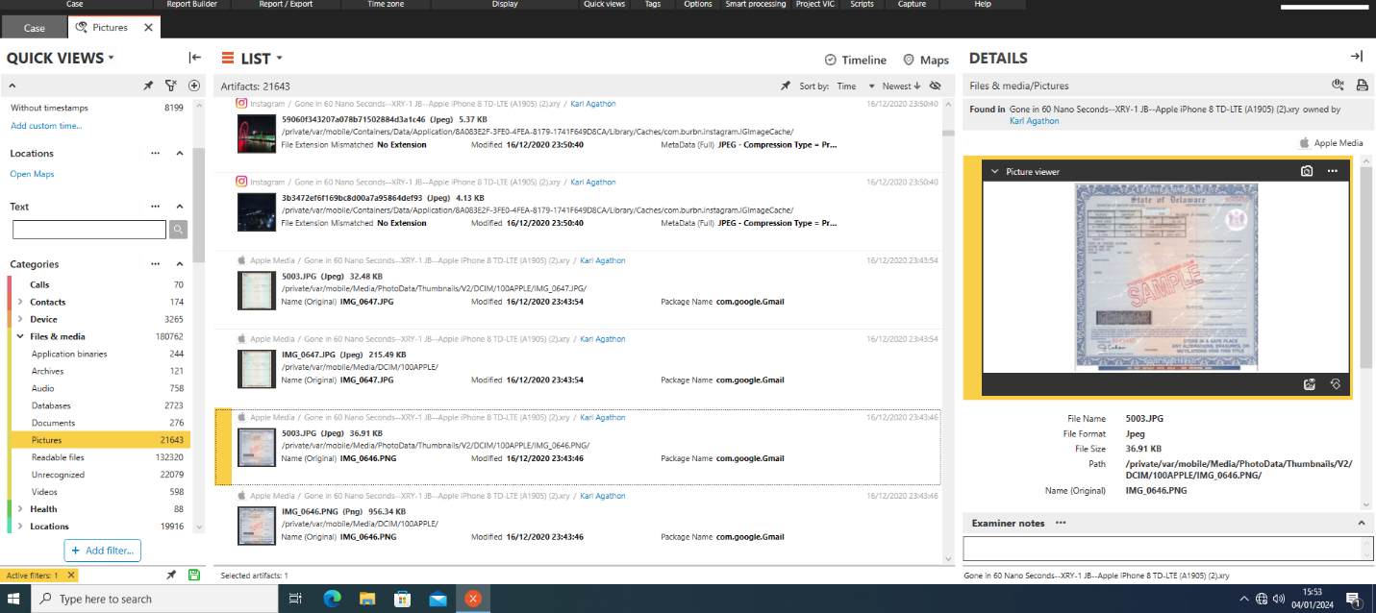

On 16/12/20 some send him a Picture of Canadian currency notes by SMS/MMS.

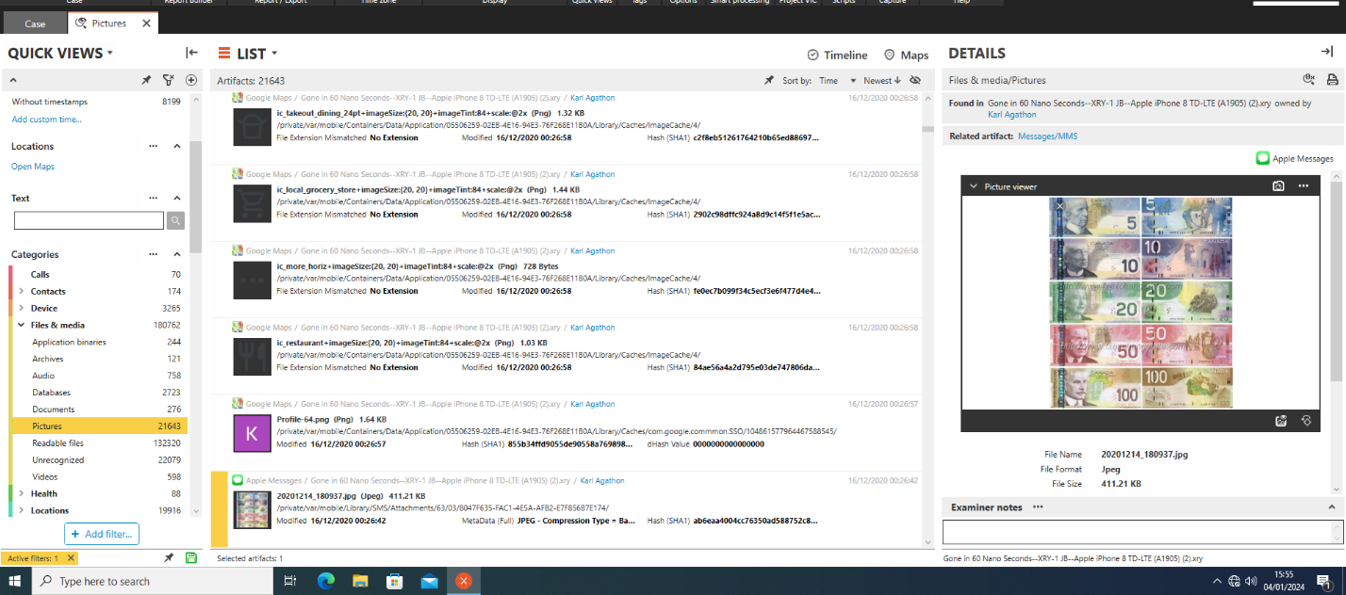

In this photo its clearly written “Restoring Application KeepSafe” from the URL of com.kii.safe. It may be possible this is the same Samsung Galaxy J3 device.

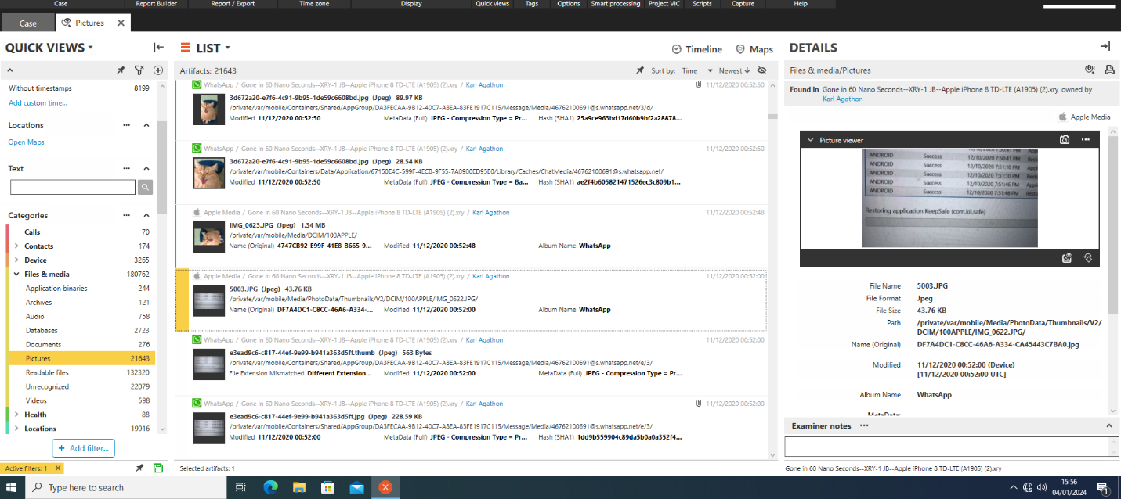

In this Jpeg picture that came by WhatsApp application. There are different types of guns. Its suspicious to me.

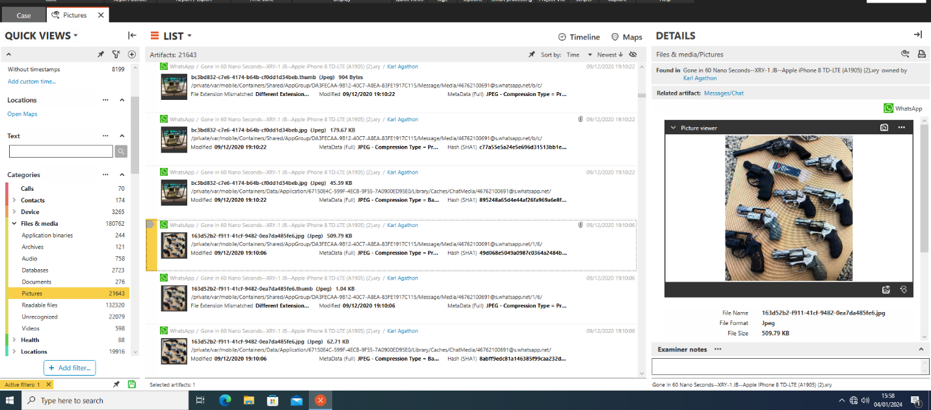

In this image file I found so many different types old keypad phones. Nowadays these phones are very rarely in use. It is possible they use this phone on the moment of crime.

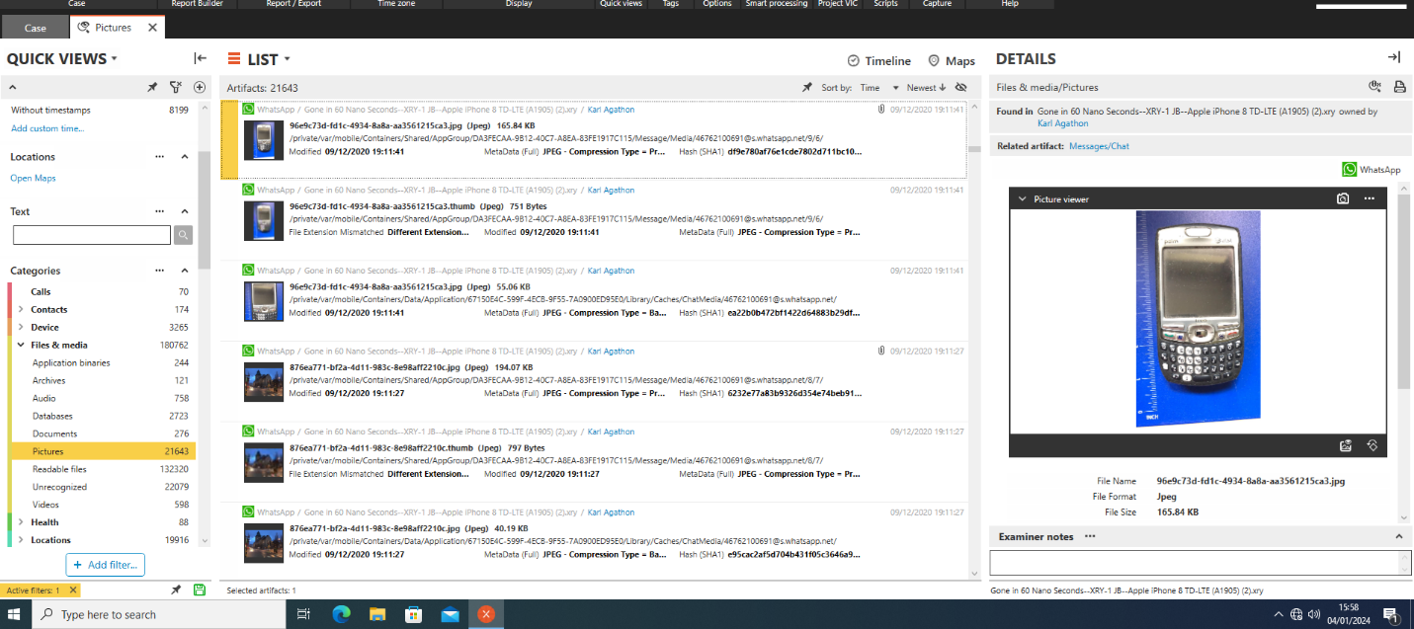

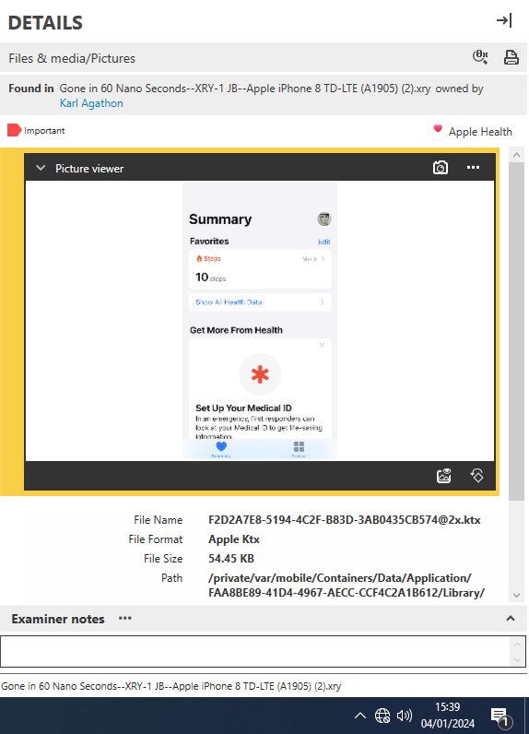

In this Screenshot we can see that I have found few bank cards. One of these is an American Express card with last 4 digits are visible to us.

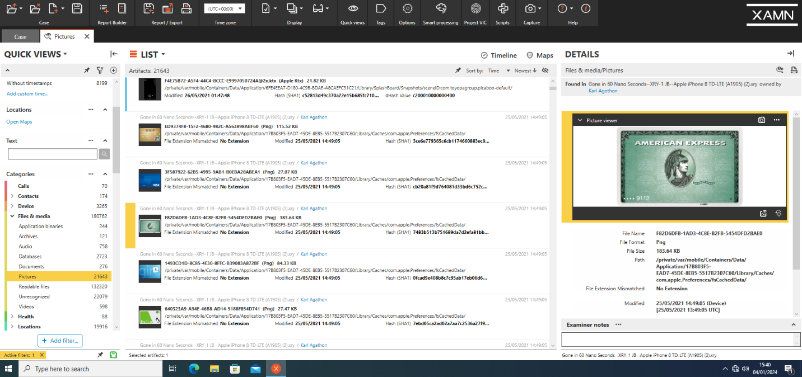

A visa card with last four digits “9112”

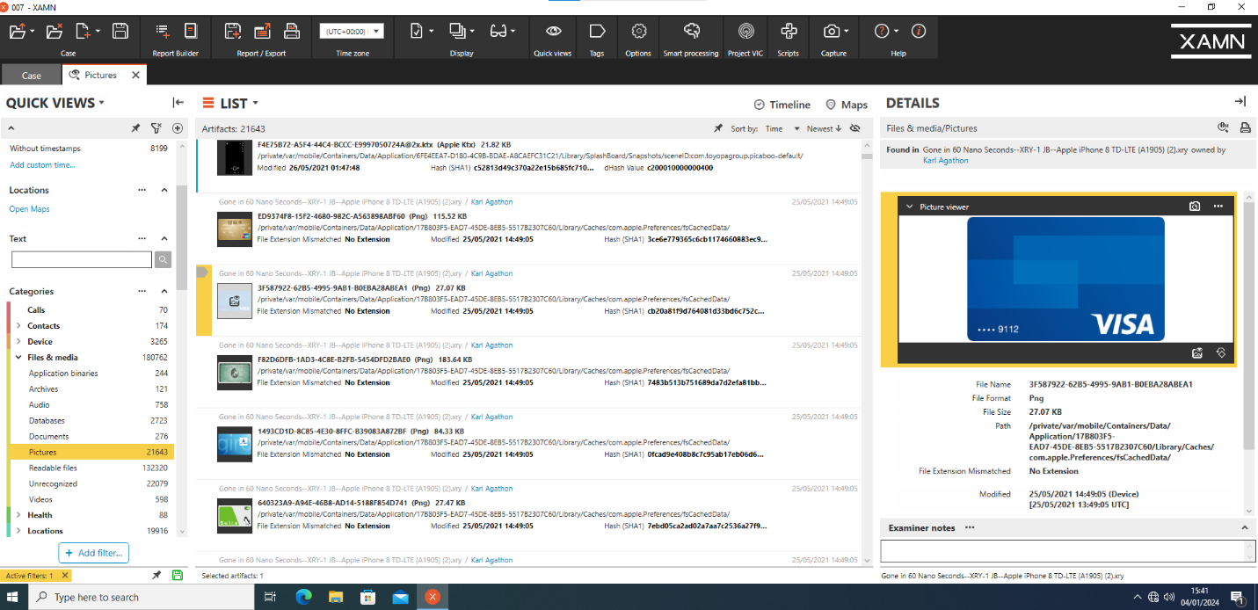

This picture is shared by someone on a WhatsApp group. Its about work to do next. He / She shared the time of event and duty.

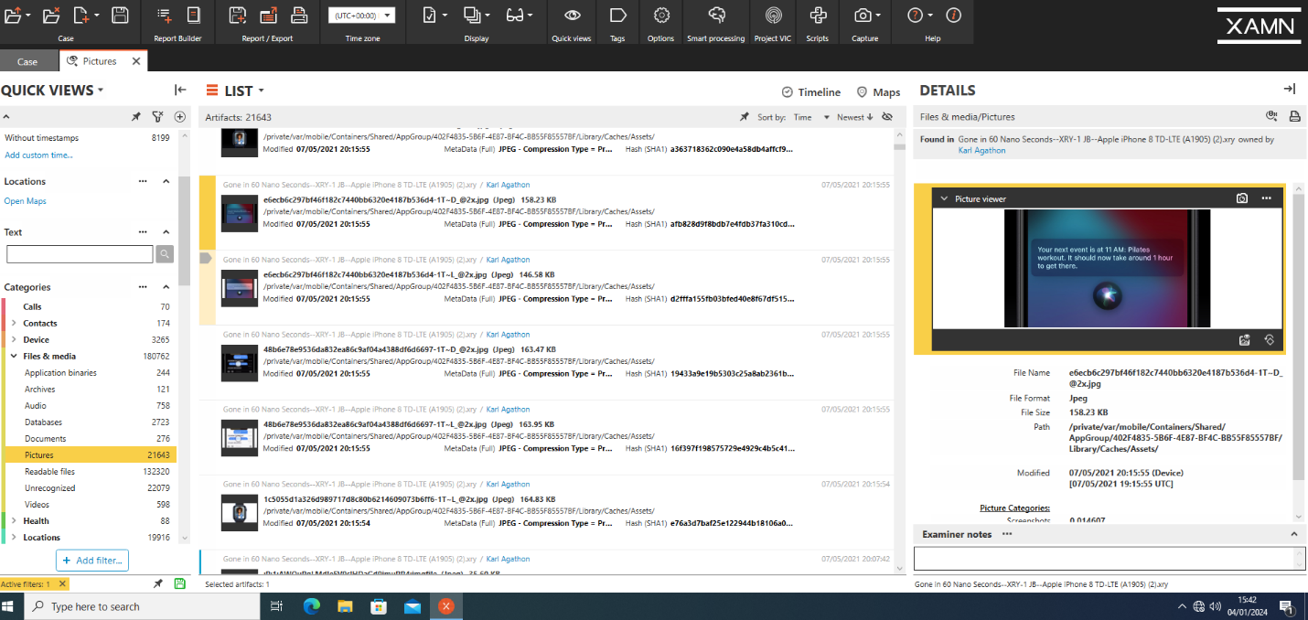

This is the metadata picture of different types and sizes of bullets. Its shared on 05 March 2021 on Kik chat application.

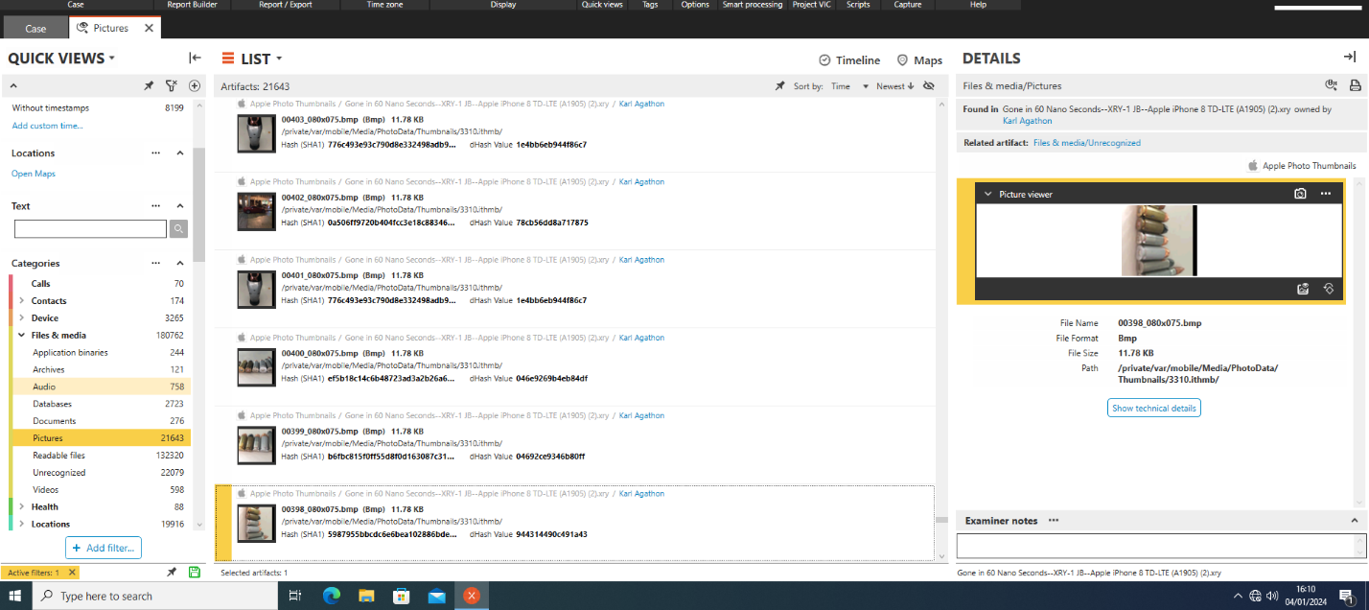

**Communication**

This is snapcode. Its use to scan to direct open someone profile. Its like a QR code but only use by Snapchat application. It has no extension but it shared on the same time like previous image.

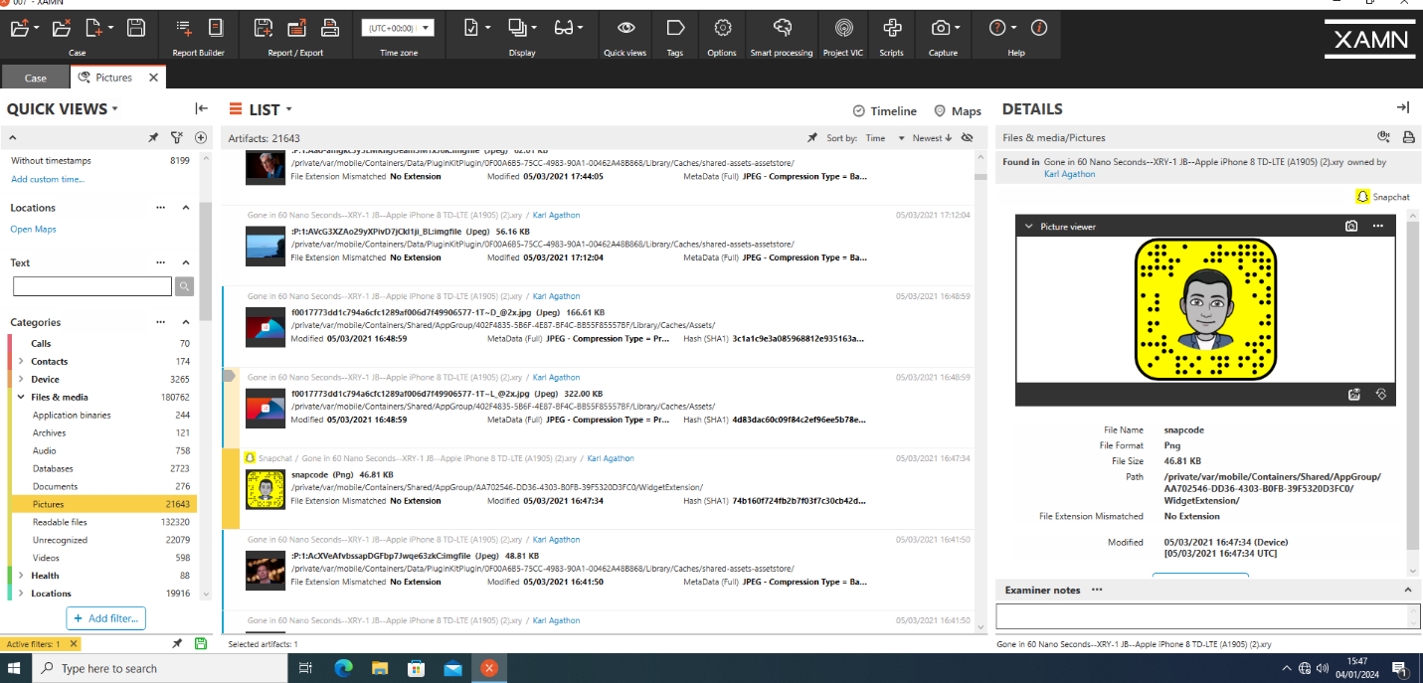

One of the suspicious picture I had scene is lots of money shared on WhatsApp application in the evening of 09/12/2020.

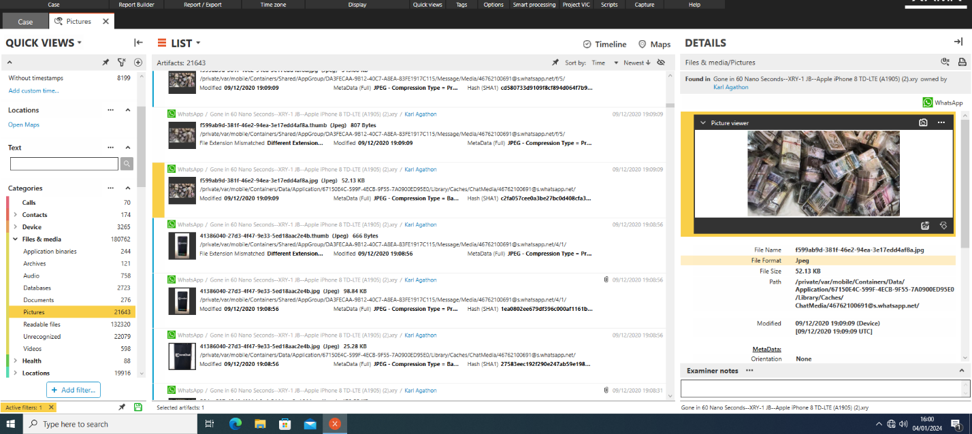

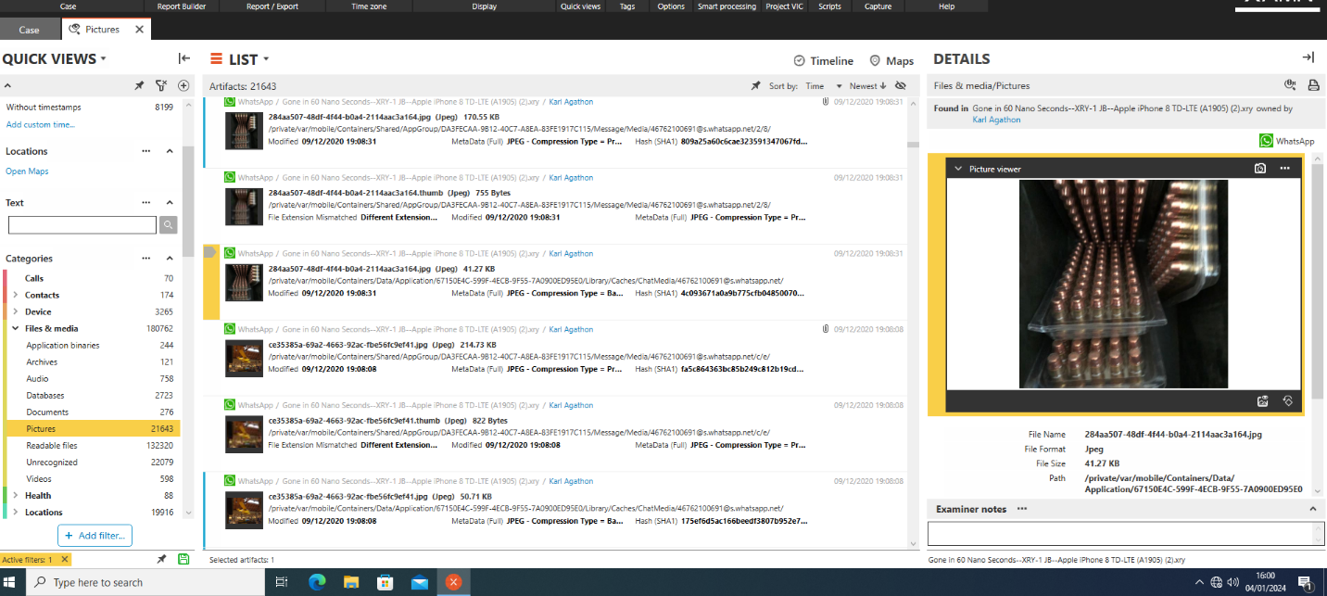

John Bear and Fozzy Bear are continuously in contact with Karl on different applications.

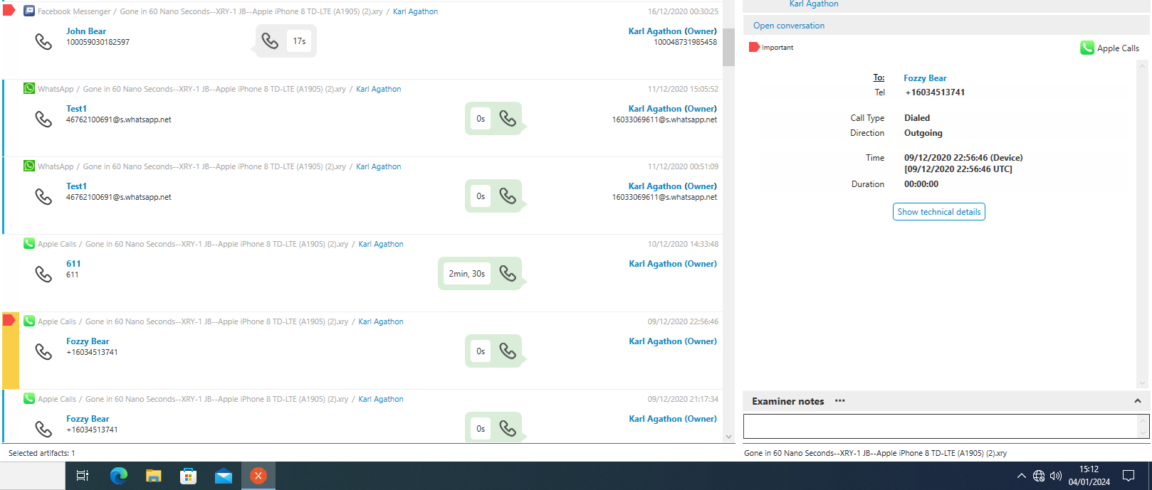

Armand Garand is in contact with Karl on many social media applications such as Kakao Talk and Apple calls. They always have a short conversation on phone call.



I’m the Warrior. Iamthewarrior is very suspicious name to me. In Addition, he called Karl few times but the noticeable thing is he had a long phone call nearly more than half an hour on Discord application. And he also texted him many times of different pattern code like OTP. 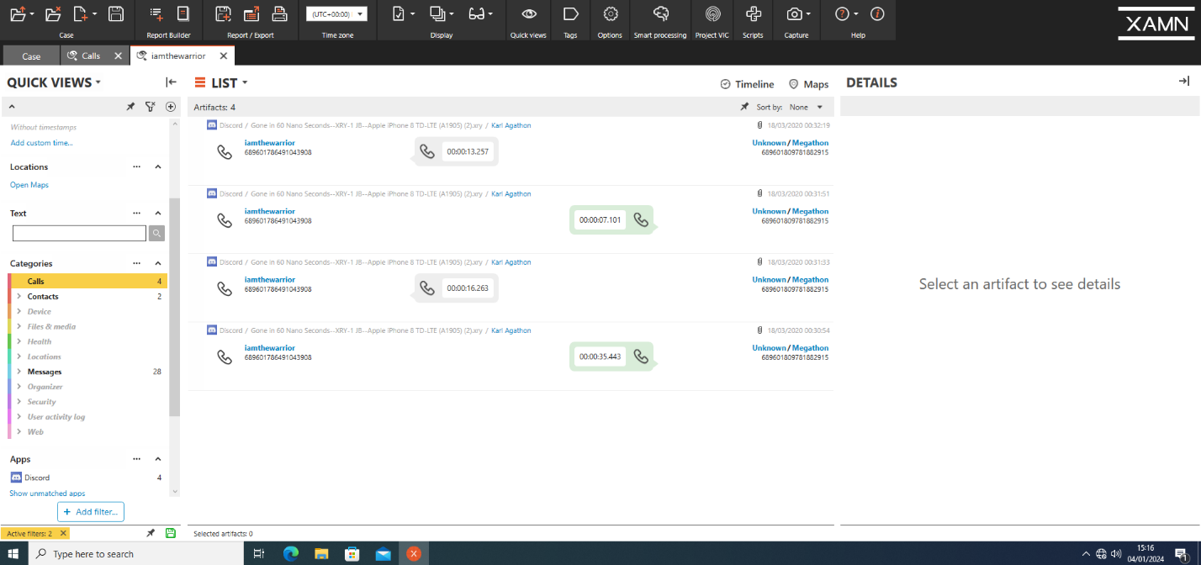

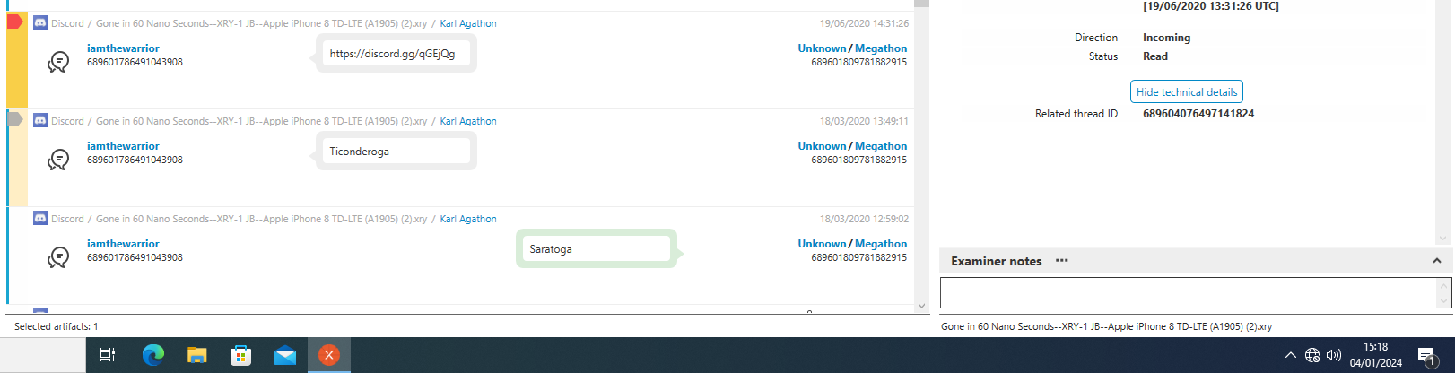

**Locations**

In this Screenshot we can see a yellow point it’s a location of video where it had recorded. We have provided an exact location with the help of Longitude and Latitude.

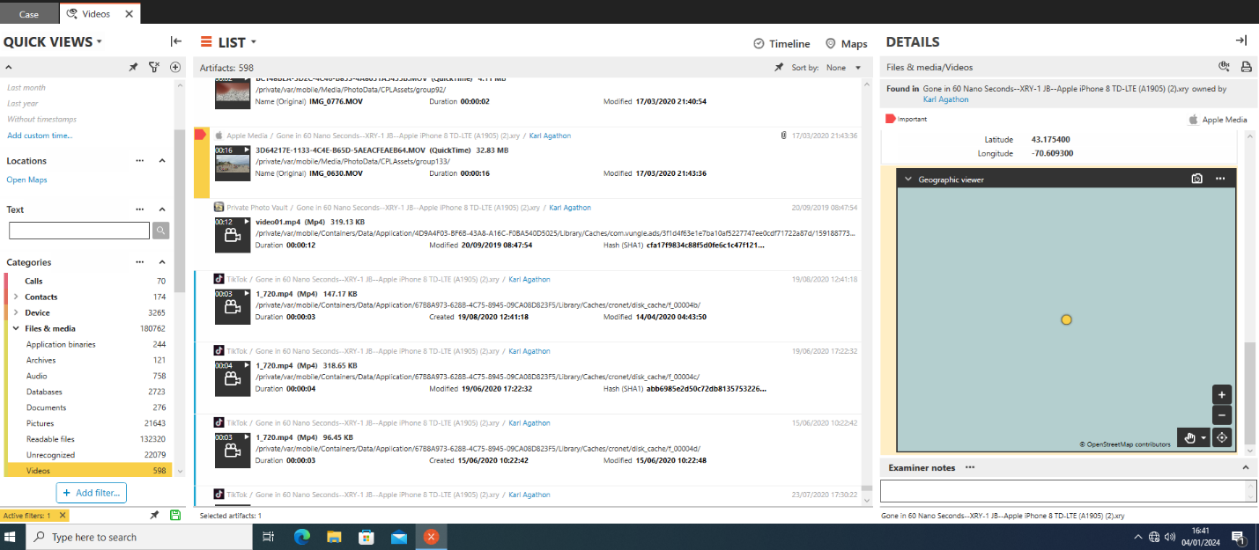

**Metadata**

We may examine this bullet picture using the HxD tool. Digital forensics and data analysis frequently employ HxD, a strong and free hex editor. With the help of this tool, users may examine and modify binary files at the hexadecimal level, providing a thorough understanding of the structure of the file. Hexadecimal content analysis (HxD) is useful for reading and interpreting files when it comes to metadata extraction. Analysts possess the ability to traverse through unprocessed data, recognise trends, and decipher metadata contained within the file. Users can learn details about file properties, timestamps, and other metadata that are essential for forensic investigations and data analysis by looking at the hex representation.

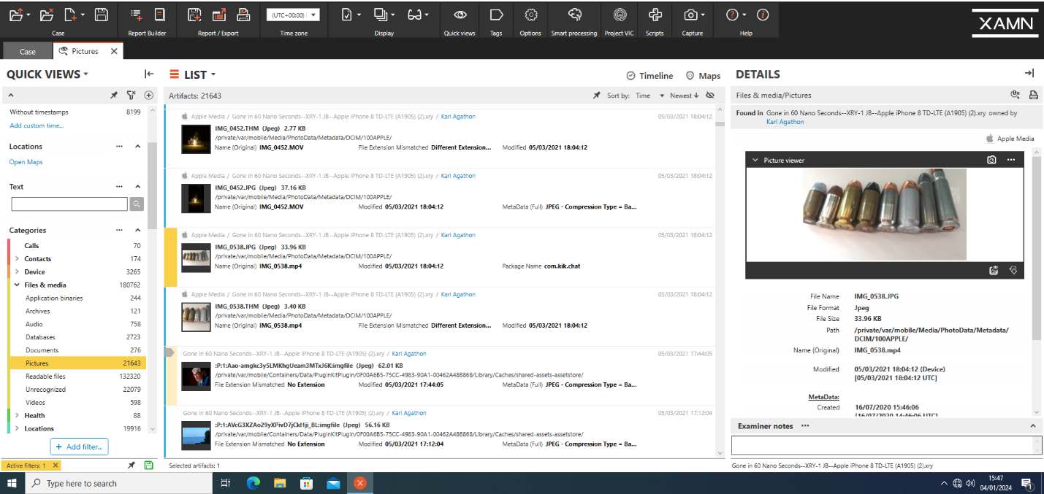

**List Evidence**

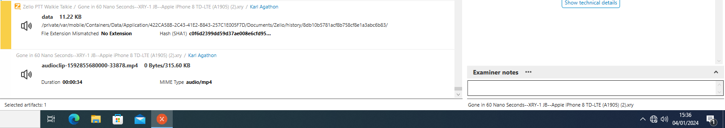

Bullet ronny used

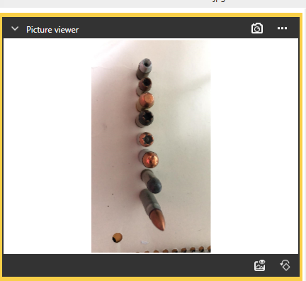

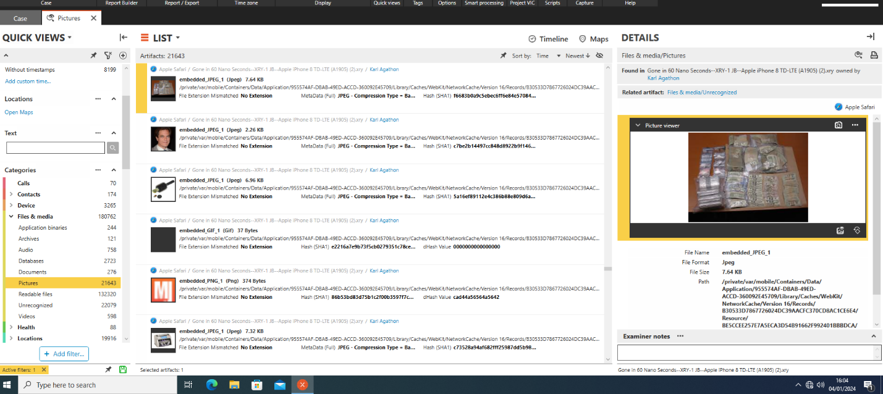

I've discovered a crucial voice memo. This audio file was listened to by me. While speaking to others, one man warned others to be on the lookout for anyone who would be an easy target for us. They had a car theft planned. This audio file was obtained via Zello PTT Walkie Talkie. Its file name is data, which is subject to change, and its format is Ogg. It has no extension.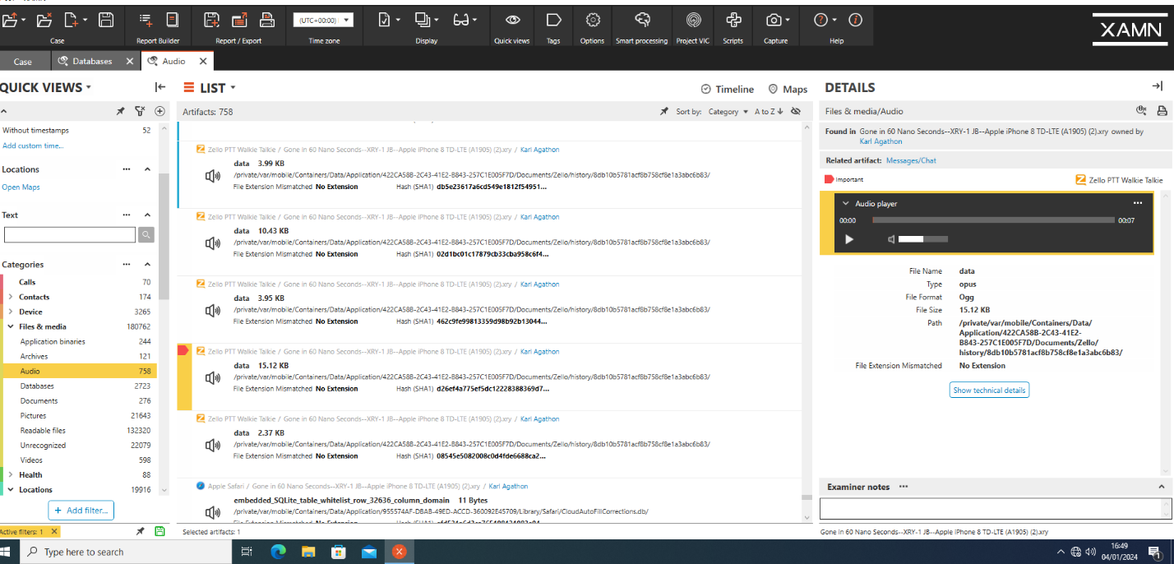

The official license number of Karl is written by a pen on a piece of paper.

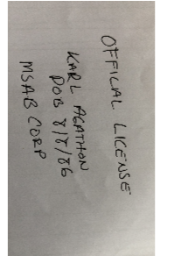

Passport of lady

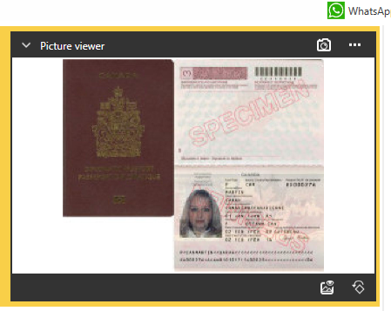

Police badge

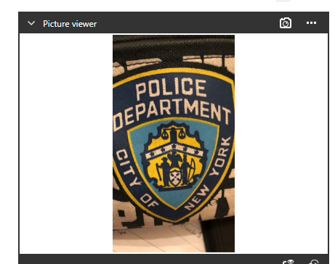

Ronny badge

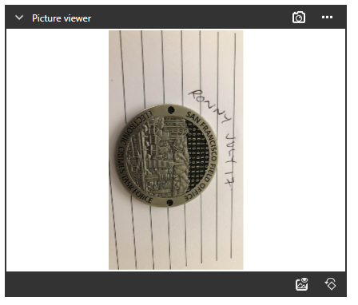

Secret agent

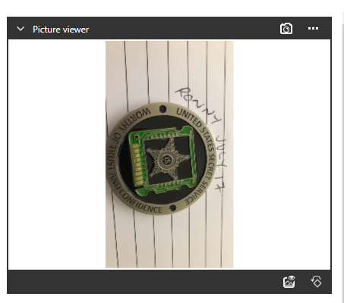

Shooter gun

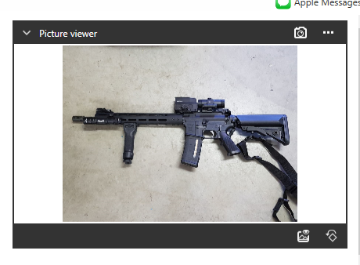

Usb for investigation

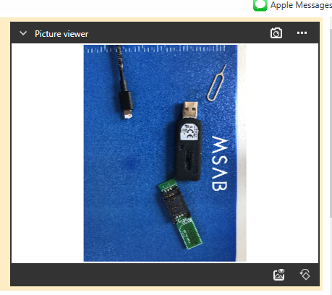

Cards of different banks

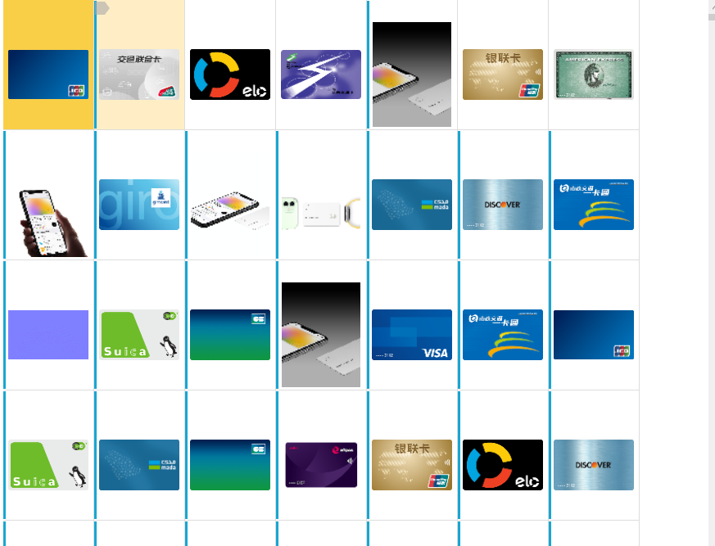

**SQLite**

SQLite functions as a single regular file since it is a serverless, self-contained relational database management system (RDBMS). The complete database is included on a single disc file in this file, which is frequently labelled with the ".db" extension. This makes it extremely manageable and portable. The SQLite library is incorporated directly into the application code, allowing it to communicate with the database file locally on the user's device.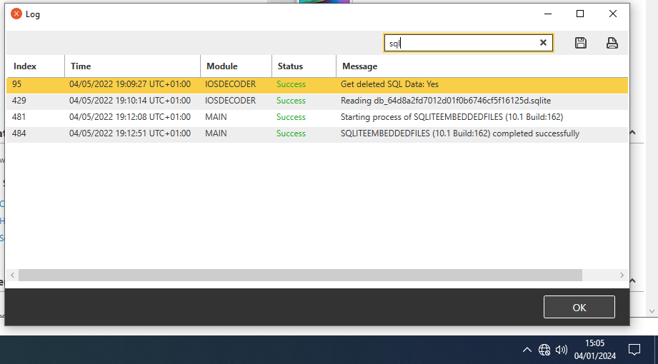

**How SQLite Works on Phones:**

SQLite databases are generally kept on mobile devices in app-specific folders or internal storage. Because they are a component of the application sandbox, data security and isolation are guaranteed. Tables, indexes, and other structural elements are included in the SQLite file to help with data organisation and retrieval.

SQLite databases are essential to the architecture of mobile applications in order to enable offline functionality. Data is read from or written to the device's SQLite database file as a user interacts with the programme, enabling a fluid and responsive user experience.

**SQLite in WhatsApp and Facebook:**

Numerous kinds of data, including media files, contact details, and message content, are stored in WhatsApp's SQLite database file. Usually, the file can be found in the app's internal storage location. The amount of media shared, the volume of communications, and user activity can all affect the database's size.

Similar to this, SQLite is used for local data management in Facebook's mobile application. Posts, comments, and other content from users are included in this. Variable file sizes result from the SQLite file in the app's directory changing based on user interactions and content creation.

**Retrieve/Recovery Data**

Some important data appears to have been removed from the original, jailbroken smartphone. In actuality, jailbreaking an iPhone voids its warranty because it involves removing restrictions via hardware and software exploits and granting root access to the file system.

| **Application** | **Items** | **Deleted Items** |
| --- | --- | --- |
| WhatsApp | 524 | 1 |
| WhatsApp Business | 4233 | 1 |
| Viber | 1875 | 1 |
| Yahoo Mail | 318 | 0 |
| Youtube | 316 | 0 |
| Zello PTT | 4 | 0 |
| Apple Backup Info | 291 | 36 |

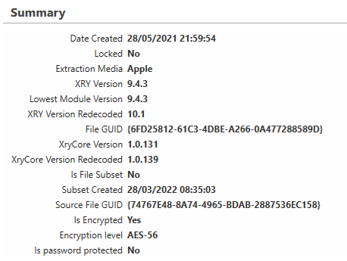

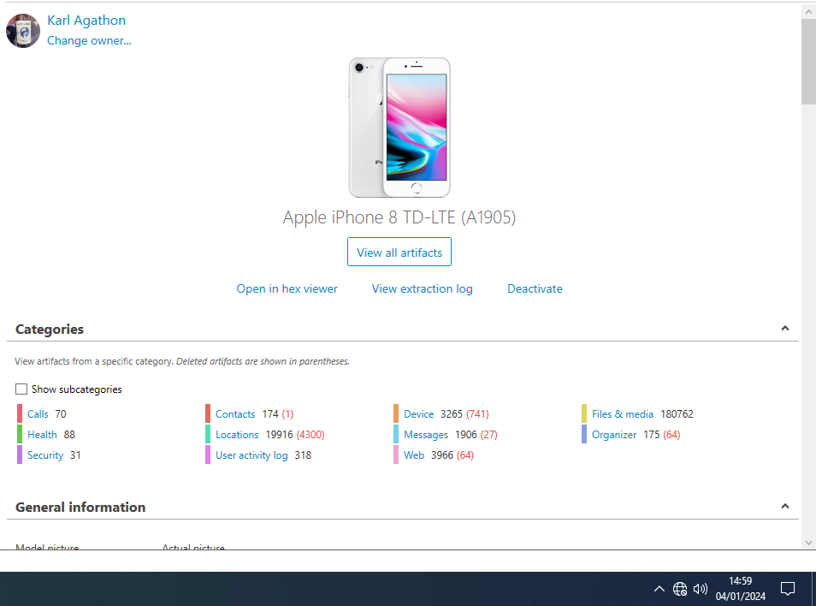

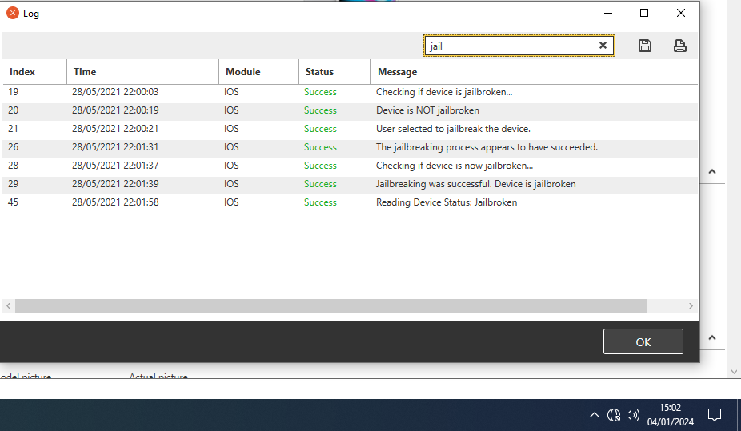

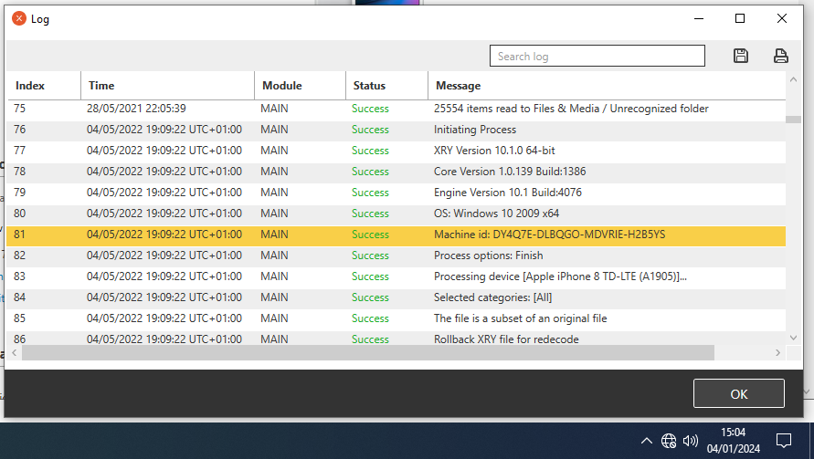

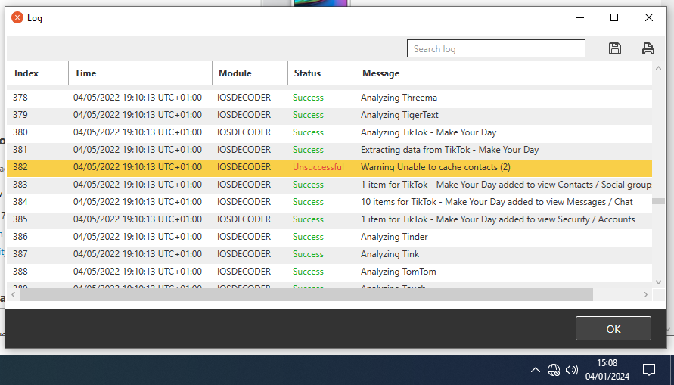

**XAMN Element**

A complete digital forensics programme called XAMN is made to examine and display data that has been taken from mobile devices.

The user interface used to examine and evaluate the retrieved data is called XAMN Viewer. It gives forensic analysts a visual depiction of the data gleaned from mobile devices, enabling them to analyse, sort, and present the results.

Key features of XAMN Viewer may include:

1. **Data Visualization:** Forensic investigators can navigate through the data recovered from mobile devices more easily because to XAMN Viewer's structured and organised data presentation.
2. **User-Friendly Interface:** Typically, the tool provides an easy-to-use interface that makes it possible for investigators to successfully engage with the data. It might offer a range of perspectives and settings to personalise the information display.
3. **Advanced Filtering and Searching:** XAMN Viewer frequently has strong filtering and searching features that let forensic investigators concentrate on particular data points or interesting patterns.
4. **Report Generation:** An essential component of investigations is forensic documentation. Features for creating comprehensive reports based on the examined data may be included in XAMN Viewer. These reports can be utilised for legal or investigative reasons.
5. **Multimedia Analysis:** XAMN Viewer most likely facilitates the analysis of photos, movies, and other multimedia files recovered during forensic examinations, given the abundance of multimedia material on mobile devices.
6. **Data Correlation:** With the use of this technology, analysts could be able to correlate data from various sources within the material that has been retrieved, leading to a more thorough comprehension of the case.

**Metadata of transferred data from a source:**

Descriptive information about data, such as creation date, author, file size, and format, are referred to as metadata. It provides information on the qualities and whereabouts of digital content, making management, retrieval, and organisation more effective. Metadata is essentially a critical component of several disciplines, such as data management, library science, and digital forensics, since it improves comprehension and accessibility.

Essential data related to digital evidence that is taken from mobile devices for forensic investigations is referred to as metadata. This contains information from communication logs, file properties, timestamps, device identifiers, and geolocation data. XRY is an expert at removing metadata from mobile devices so that important details about user behaviour can be seen. As a forensic analysis tool, XAMN makes use of this metadata to provide an extensive and well-structured view of the extracted data. This helps investigators comprehend the relationships, context, and timelines found in the digital evidence, which ultimately helps the forensic analysis process go more smoothly.

**Executive Summary**

The forensic analysis of the iPhone 8 image file, conducted through XAMN software, has revealed a multifaceted narrative of digital evidence. Noteworthy findings include police or security badges, Karl's license number, consistent communication with individuals John Bear, Fozy Bear, and Armand Garand, a concerning voice note within the Zello PTT walkie-talkie application, various bank cards, and sample certificates. These discoveries introduce critical dimensions to the investigation, involving potential ties to law enforcement, communication patterns, troubling instructions, financial implications, and documents hinting at possible misuse. The complex nature of the digital evidence calls for a meticulous inquiry into each facet, providing a comprehensive understanding of Karl's activities, affiliations, and potential involvement in illicit or concerning behaviors.